Q1.High-level performance
SELECT SUM(total_amount) AS total_revenue FROM fact_sales;
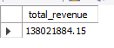
Q2.Average Order Value
select round(AVG(total_amount),2) as Avg_Revenue from fact_sales;
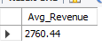
Q3.No of Customer by Customer Segmentation
select customer_segment,count(*) As Count_of_Customer
from dim_customers
group by customer_segment
order by Count_of_Customer DESC;
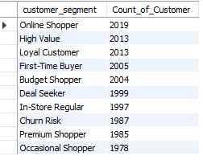

Q4.Customer Geography
SELECT residential_location, COUNT(*) As No_of_Customers
FROM dim_customers
GROUP BY residential_location
ORDER BY No_of_Customers DESC limit 10;

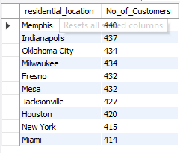
Q5.Top Customers by Spending
SELECT
c.first_name,
c.last_name,
SUM(f.total_amount) AS total_spending
FROM fact_sales f
JOIN dim_customers c
ON f.customer_sk = c.customer_sk
GROUP BY c.customer_sk, c.first_name, c.last_name
order by total_spending DESC limit 10;
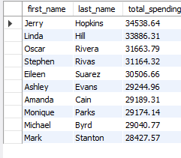
Q6.Purchase Frequency
SELECT c.first_name, COUNT(*) AS purchases
FROM fact_sales f
JOIN dim_customers c
ON f.customer_sk = c.customer_sk
GROUP BY f.customer_sk
ORDER BY purchases DESC limit 10;
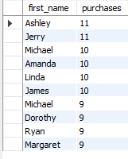

Q7.Store Distribution
SELECT store_type, COUNT(*) As Count_of_Stores
FROM dim_stores
GROUP BY store_type
order by Count_of_Stores DESC;
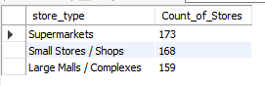
Q8.Store Revenue
Select store_name,round(AVG(total_amount),2) As Revenue
from fact_sales
join dim_stores
on fact_sales.store_sk = dim_stores.store_sk
group by store_name
order by Revenue DESC limit 10;
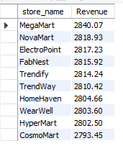
Q9.Store-wise transactions
Select s.store_name,count(*) As transactions
from fact_sales f
join dim_stores s
on f.store_sk = s.store_sk
group by s.store_name
order by transactions DESC limit 10;
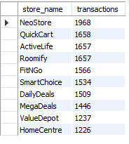
Q10.Customers per Store
SELECT store_name, COUNT(DISTINCT customer_sk) No_of_Customers
FROM fact_sales f
JOIN dim_stores s
ON f.store_sk = s.store_sk
GROUP BY store_name
order by No_of_Customers DESC limit 10;
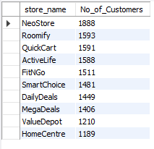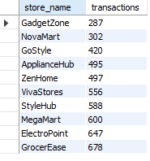
Q11.Highest selling store per product category.
Select p.category,s.store_name,SUM(f.total_amount) as Revenue
from fact_sales as f
join dim_products as p
on f.product_sk = p.product_sk
join dim_stores as s
on f.store_sk = s.store_sk
group by p.category,s.store_name
order by Revenue desc limit 10;
desc ASC
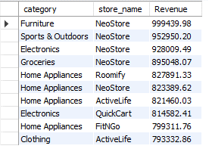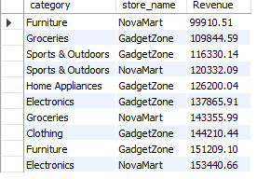
Q12.Product count by category.
Select category,count(*) as Product_count_by_category
from dim_products
group by category
order by Product_count_by_category DESC ;
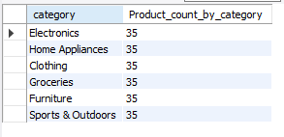

Q13.Product count by BRAND
Select brand,count(*) as Product_count_by_brand
from dim_products
group by brand
order by Product_count_by_brand DESC limit 10;
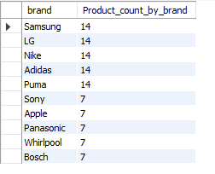
Q14. Revenue Generate By Store Type
Select s.store_type , Sum(f.total_amount) AS Revenue_Contribution
from fact_sales as f
join dim_stores as s
on f.store_sk = s.store_sk
group by s.store_type
order by Revenue_Contribution DESC;
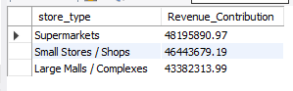
Q15.Total revenue by product category.
Select p.category,SUM(f.total_amount) As Revenue
from fact_sales AS f
join dim_products as p
on f.product_sk = p.product_sk
group by p.category
order by Revenue desc limit 10;

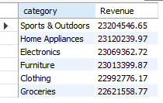
Q16.Total revenue by product brand.
Select p.brand,SUM(f.total_amount) As Revenue
from fact_sales AS f
join dim_products as p
on f.product_sk = p.product_sk
group by p.brand
order by Revenue desc limit 10;
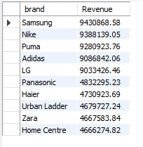
Q17.Total Revenue by the Customer Segments
Select c.customer_segment,Sum(f.total_amount) As Revenue
from fact_sales as f
join dim_customers as c
on f.customer_sk = c.customer_sk
group by c.customer_segment
order by Revenue DESC ;
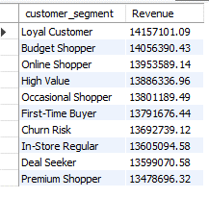
Q18.Total revenue by customer_residential_location:
select c.residential_location, Sum(f.total_amount) AS Revenue
From fact_sales as f
Join dim_customers as c
on f.customer_sk = c.customer_sk
group by c.residential_location
order by Revenue limit 10;
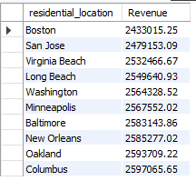
Q19. Revenue by Location
Select s.store_location , SUM(f.total_amount) As Revenue
from fact_sales as f
join dim_stores as s
on f.store_sk = s.store_sk
group by s.store_location
order by Revenue desc LIMIT 10;
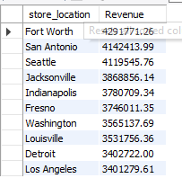

Q20.Revenue contribution by customer segment.

select c.customer_segment , sum(f.total_amount) as Revenue
from fact_sales as f
join dim_customers as c
on f.customer_sk = c.customer_sk
group by c.customer_segment
order by Revenue desc ;
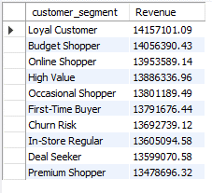
Q21.Customer distribution by residential location.

select residential_location,count(*) as customers
from dim_customers
group by residential_location
order by customers desC limit 5;
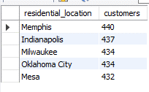
Q.22 Top 10 best-selling products by revenue.

select p.product_name,sum(f.total_amount) as Revenue
from fact_sales as f
join dim_products as p
on f.product_sk = p.product_sk
group by p.product_name
order by Revenue DESC Limit 10;
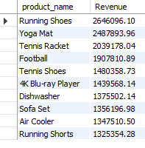
Q23.Least 10 products selling by revenue.
select p.product_name,sum(f.total_amount) as Revenue
from fact_sales as f
join dim_products as p
on f.product_sk = p.product_sk
group by p.product_name
order by Revenue Limit 10;
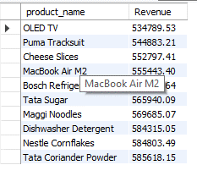
Q24 Top products by sales count

select p.product_name,Count(*) as Sales
from fact_sales as f
join dim_products as p
on f.product_sk = p.product_sk
group by p.product_name
order by Sales DESC Limit 10;
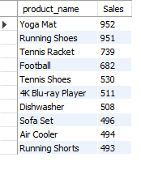
Q25.Category-wise average product revenue.
Select p.category,round(AVG(f.total_amount),2) AS Avg_revenue
from fact_sales as f
join dim_products as p
on f.product_sk = p.product_sk
group by p.category
order by Avg_revenue DESC;
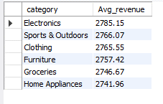
Q26. Product performance by store type.
Select p.product_name,s.store_type,SUM(f.total_amount) as Revenue
from fact_sales as f
join dim_products as p
on f.product_sk = p.product_sk
join dim_stores as s
on f.product_sk = s.store_sk
group by p.product_name,s.store_type
order by Revenue DESC limit 10;
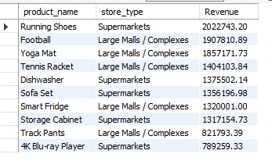
Q27.Category WISE ranking
SELECT
category,
product_name,
revenue,
RANK() OVER (
PARTITION BY category
ORDER BY revenue DESC
) AS rank_in_category
FROM (
SELECT
p.category,
p.product_name,
SUM(f.total_amount) AS revenue
FROM fact_sales f
JOIN dim_products p
ON f.product_sk = p.product_sk
GROUP BY
p.category,
p.product_name
) t;

Q28.Month-over-Month Revenue Growth (dim_dates)

WITH monthly_sales AS (
SELECT
d.year,
d.month,
SUM(f.total_amount) AS revenue
FROM fact_sales f
JOIN dim_dates d
ON DATE(f.sales_date) = d.full_date
GROUP BY d.year, d.month
),
growth_calc AS (
SELECT *,
LAG(revenue) OVER (ORDER BY year, month) AS prev_month_revenue
FROM monthly_sales
)
SELECT *,
ROUND((revenue - prev_month_revenue) / prev_month_revenue * 100, 2)
AS growth_percentage
FROM growth_calc;
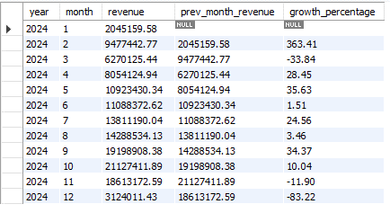

Q29.Does revenue depend on weekends?
Select CASE
WHEN weekday IN(6,7) THEN "Weekend"
ELSE "Weekday"
END AS day_type,
Sum(f.total_amount) as Revenue
from fact_sales as f
join dim_dates as d
on date(f.sales_date) = d.full_date
group by day_type;
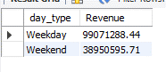
Q3O.DAY WISE REVENUE
Select CASE
WHEN weekday=1 THEN "Monday"
WHEN weekday=2 THEN "Tuesday"
WHEN weekday=3 THEN "Wednesday"
WHEN weekday=4 THEN "Thursday"
WHEN weekday=5 THEN "Friday"
WHEN weekday=6 THEN "Saturday"
WHEN weekday=7 THEN "Sunday"
END AS day_type,
Sum(f.total_amount) as Revenue
from fact_sales as f
join dim_dates as d
on date(f.sales_date) = d.full_date
group by day_type
order by Revenue DESC;

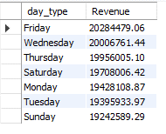
Q31.Which campaigns actually deserve budget?

with campaings_revenue AS(
select c.campaign_name,c.campaign_budget, Sum(f.total_amount) as Revenue
from fact_sales as f
join dim_campaigns as c
on f.campaign_sk = c.campaign_sk
group by c.campaign_name,c.campaign_budget
)
Select *,ROUND((Revenue-campaign_budget)/campaign_budget*100,2)
as ROI
from campaings_revenue
order by ROI desc;
Green Weekend Deals | 105815.00 | 2741038.33 | 2490.41
Instant Gratification Sale | 165155.00 | 2789495.41 | 1589.02
New Arrival Showcase | 191922.00 | 2837418.18 | 1378.42
12 Days Of Deals | 197440.00 | 2824970.79 | 1330.80
Mega Weekend Bonanza | 231714.00 | 2754701.71 | 1088.84
Deal Of The Month | 288069.00 | 2717381.79 | 843.31
Autumn Deals Drive | 294276.00 | 2703644.13 | 818.74
Shop & Save Spectacular | 287542.00 | 2591893.85 | 801.40
Customer Appreciation Week | 364556.00 | 2940561.29 | 706.61
Smart Shopper Week | 361952.00 | 2897700.44 | 700.58
Black Friday Blowout | 350598.00 | 2740920.26 | 681.78
New Product Launch Promo | 338439.00 | 2637307.59 | 679.26
Golden Hour Bargains | 390827.00 | 2941476.60 | 652.63
Cart Crasher Campaign | 345327.00 | 2564215.06 | 642.55
Ultimate Value Event | 372846.00 | 2658042.84 | 612.91
Spring Splash Discounts | 372105.00 | 2650721.10 | 612.36
Midnight Madness | 396601.00 | 2811875.64 | 608.99
Hot Picks Promo | 427832.00 | 2762956.83 | 545.80
Cashback Carnival | 430018.00 | 2754664.15 | 540.59
Double Points Bonanza | 457117.00 | 2776425.45 | 507.38
Festive Fever Promo | 490622.00 | 2895075.26 | 490.08
End Of Season Sale | 459061.00 | 2657384.28 | 478.87
Summer Sizzle Promo | 480660.00 | 2771884.82 | 476.68
Winter Wonders Sale | 492696.00 | 2779564.75 | 464.15
Back To School Boost | 461504.00 | 2598343.91 | 463.02
Holiday Shopping Rush | 534045.00 | 2803715.15 | 425.00
Exclusive Insider Offers | 535298.00 | 2734366.37 | 410.81
Weekend Warrior Specials | 513019.00 | 2612158.86 | 409.17
Bogo Blitz | 560083.00 | 2771635.55 | 394.86
New Year Kickoff | 581298.00 | 2862353.03 | 392.41
Gift More, Spend Less | 585808.00 | 2608975.06 | 345.36
Winter Clearance Carnival | 640535.00 | 2834458.97 | 342.51
Super Savings Week | 681805.00 | 2841584.37 | 316.77
Red Tag Clearance | 701892.00 | 2710342.83 | 286.15
Birthday Bash Sale | 759068.00 | 2906901.72 | 282.96
Cyber Monday Mania | 724912.00 | 2735578.35 | 277.37
Clearance Countdown | 831755.00 | 2818915.47 | 238.91
Seasonal Surprise Box | 802394.00 | 2614998.11 | 225.90
Spring Refresh Event | 896201.00 | 2874565.61 | 220.75
Price Drop Parade | 880988.00 | 2797311.33 | 217.52
Happy Hour Discounts | 907340.00 | 2846018.93 | 213.67
Mystery Discount Days | 867725.00 | 2715884.18 | 212.99
Vip Access Sale | 933946.00 | 2905840.77 | 211.14
Countdown To Savings | 950065.00 | 2805567.25 | 195.30
Limited Time Treasures | 915128.00 | 2685707.54 | 193.48
Final Call Frenzy | 955663.00 | 2766912.05 | 189.53
Flash Frenzy Friday | 970860.00 | 2787682.46 | 187.14
Mid-Year Madness | 987420.00 | 2782284.09 | 181.77
Early Bird Specials | 979514.00 | 2747026.15 | 180.45
Loyalty Rewards Blast | 973542.00 | 2651435.49 | 172.35

Q32.campaings How many day work and Which campaings is large and How Much Revenue Generate

Select c.campaign_name,
d1.full_date As campaign_start_date,d2.full_date as campaign_end_date,
datediff(d2.full_date,d1.full_date) + 1 AS campaign_days,
SUM(F.total_amount) AS REVENUE
from dim_campaigns as c
join fact_sales as f
on c.campaign_sk = f.campaign_sk
join dim_dates as d1
on c.start_date_sk = d1.date_sk
join dim_dates as d2
on c.end_date_sk = d2.date_sk
group by c.campaign_name,d1.full_date,d2.full_date
order by REVENUE desc limit 10;
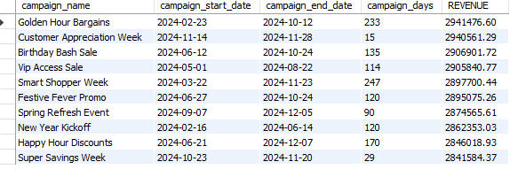

Q33.Are we over-dependent on 1 salesperson : NO
WITH salesperson_sales AS (
SELECT
salesperson_sk,
SUM(total_amount) AS revenue
FROM fact_sales
GROUP BY salesperson_sk
)
SELECT
salesperson_sk,
revenue,
ROUND(
revenue / SUM(revenue) OVER () * 100, 2
) AS contribution_percentage
FROM salesperson_sales
ORDER BY contribution_percentage DESC LIMIT 10;
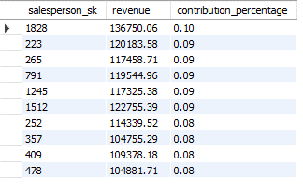
Q34.Which salesperson_role helped generate the most revenue

Select s.salesperson_role , Sum(f.total_amount) as Revenue
from fact_sales as f
join dim_salespersons as s
on f.salesperson_sk = s.salesperson_sk
group by s.salesperson_role
order by Revenue DESC;
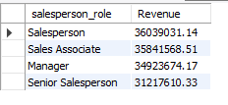
Q35.Which salesperson_role helped generate the most revenue WHERE ROLE SALESPERSON
Select s.salesperson_name,s.salesperson_role , Sum(f.total_amount) as Revenue
from fact_sales as f
join dim_salespersons as s
on f.salesperson_sk = s.salesperson_sk
group by s.salesperson_name,s.salesperson_role
having s.salesperson_role = "Salesperson"
order by Revenue DESC LIMIT 10;
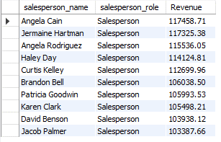
Q36.Which salesperson_role helped generate the most revenue WHERE ROLE SENIOR SALESPERSON
Select s.salesperson_name,s.salesperson_role , Sum(f.total_amount) as Revenue
from fact_sales as f
join dim_salespersons as s
on f.salesperson_sk = s.salesperson_sk
group by s.salesperson_name,s.salesperson_role
having s.salesperson_role = " Senior Salesperson"
order by Revenue DESC LIMIT 10;
